**How To Store Multiple Select Value In Laravel In Hindi**

<https://www.youtube.com/watch?v=dxWNXrMlny8&t=11s>

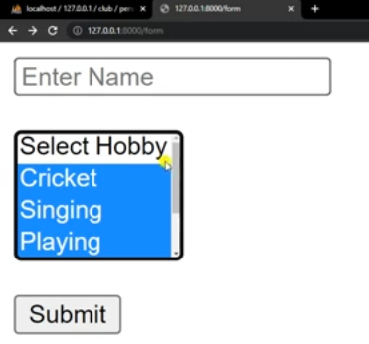

1. Table Name: **persons**

2. Model Name: **Person**

3. Controllers: **PersonController**

4. View: **Form.blade.php**

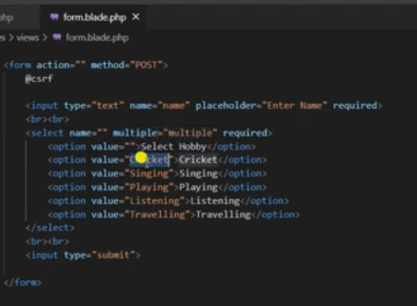

**Route**

Web.php

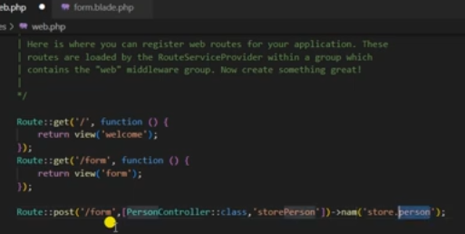

**4. View:**

**1 form.blade.php**

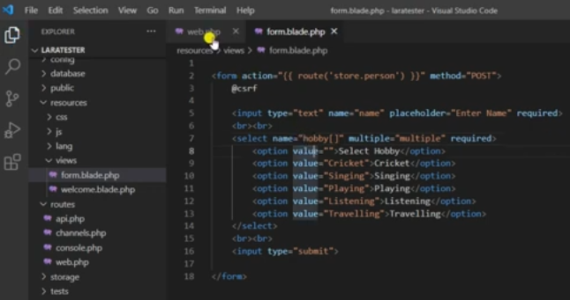

**3. PersonController:**

**TESTING:**

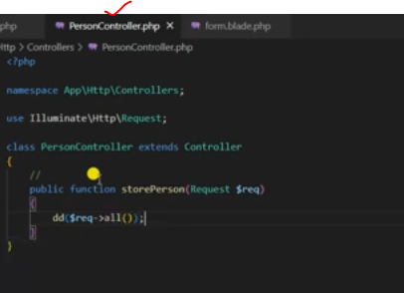

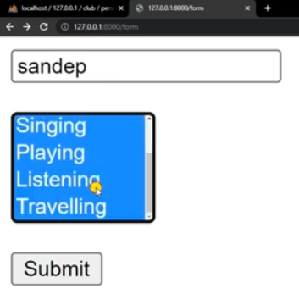

**Output:**

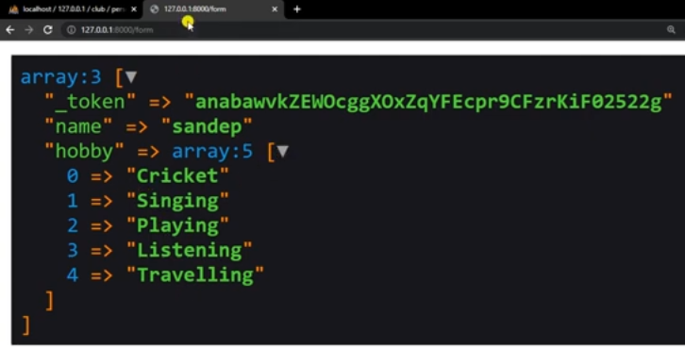

**Actual PersonalController.php code**

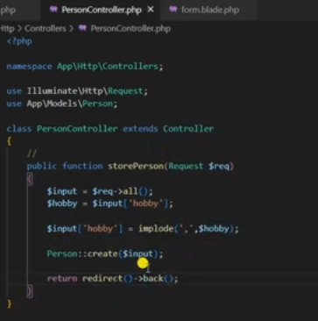

**2. Model:**

**Models🡪 Person.php**

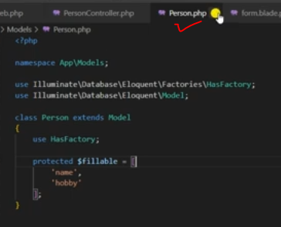

**Table name define**

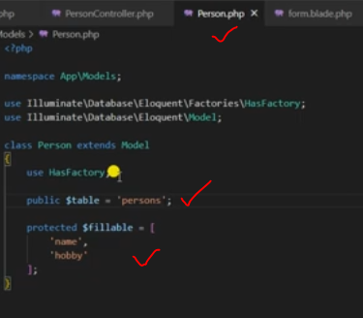

**Final**

